Use Case specification & Diagrams

Based on the analysis above the following Use cases & Actors were identified:

Actors:

1. System Administrator (hence forth referred to as Admin)

2. Company staff who perform the day to day operations of the system (hence forth referred to as staff)

3. Dealers (their staff) of the company who sell the various products of the company (hence forth referred to as Dealers)

4. Suppliers (their staff) of the company who are registered to supply Raw materials or Parts to the company (hence forth referred to as Suppliers)

The Use Cases identified are listed below. The Use case Diagram shows the Use Case & the Actors who are involved with each of the Use Cases.
1. Logging into the system
2. Entering Sales figures by the Dealers
3. Placing Orders for Products by the Dealers
4. Update received stocks of Products
5. Dispatch stocks to Dealers
6. Generate the Production Schedule report

The Use Case diagram depicting the above Use cases & the Actors involved is shown below:
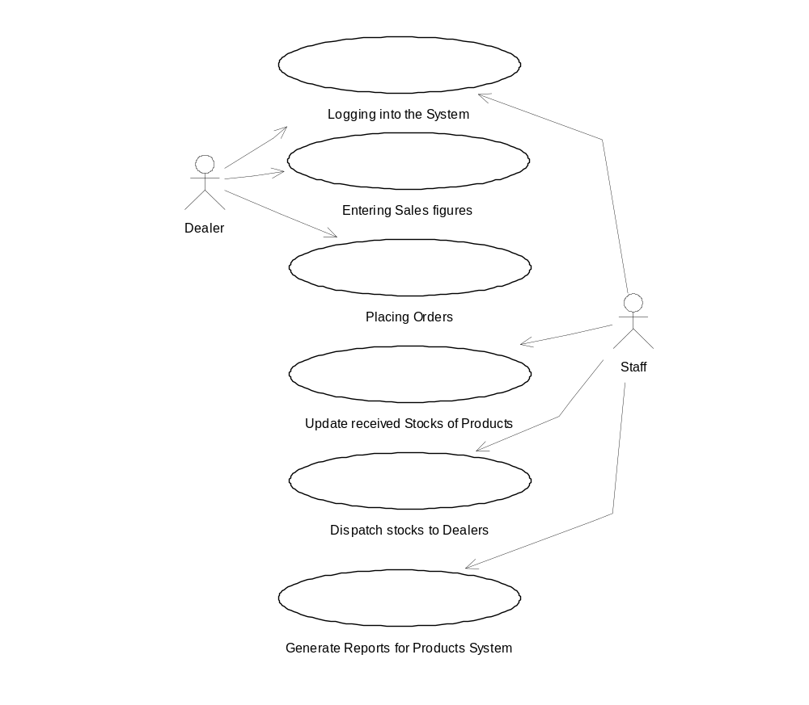
7. Generate the Parts Indent
8. Send requests to Suppliers for Quotations
9. Suppliers submit Quotations
10. Staff confirm order for Supply of Parts
11. Update Part stocks received from Suppliers
12. Update Part stocks delivered to Production Department

The Use Case diagram depicting the above Use cases & the Actors involved is shown below: 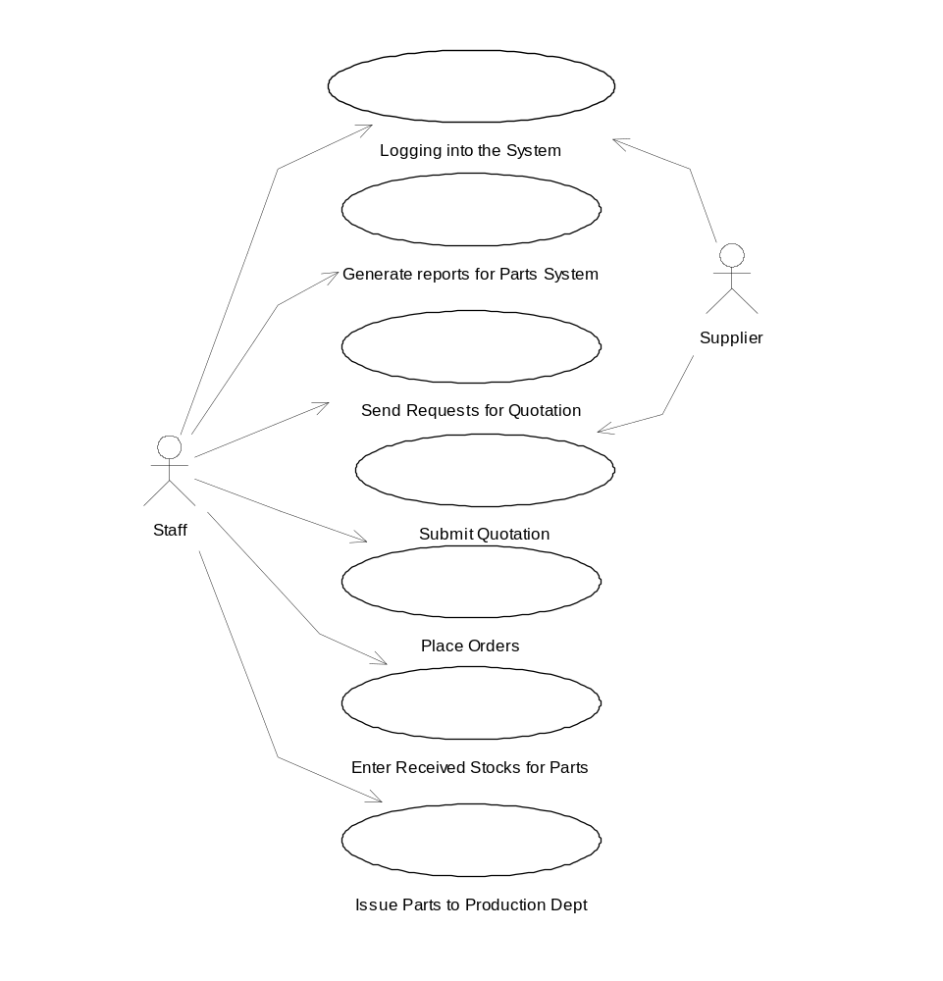

13. Add / Modify / Delete Dealers
14. Add / Modify / Delete Products
15. Add / Modify / Delete Parts
16. Add / Modify / Delete Suppliers
17. Add / Modify / Delete Users
18. Add / Modify / Delete Bill-of-Materials
19. Log out of the system

The Use Case diagram depicting the above Use cases & the Actors involved is shown below:
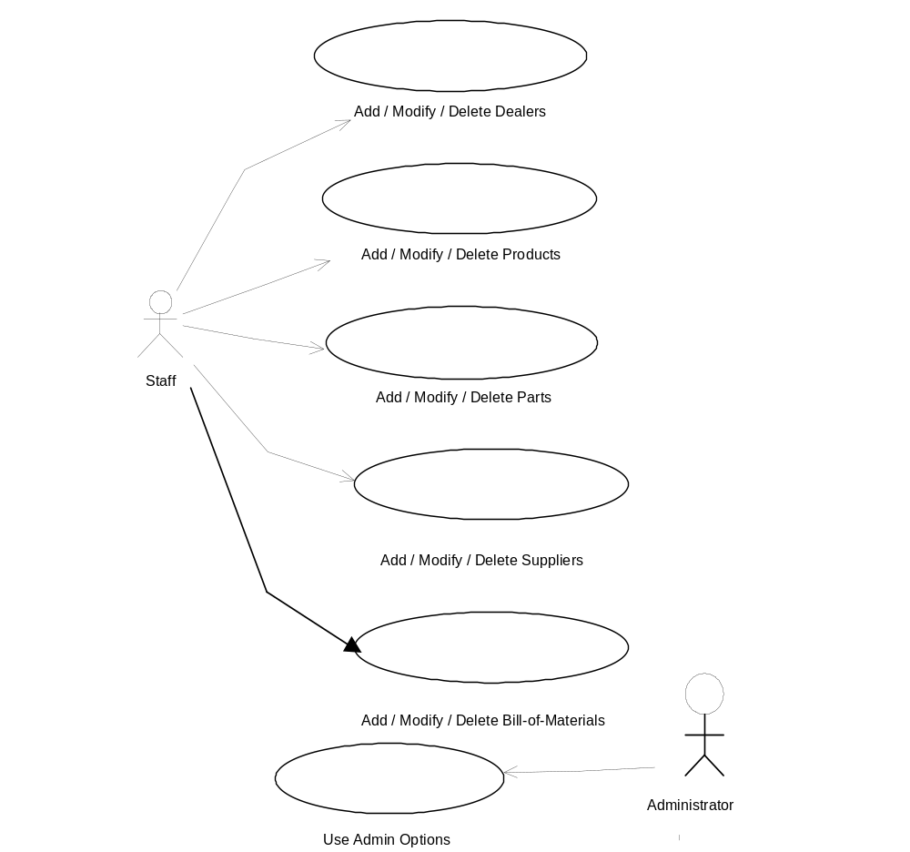
Thus the system is divided into loosely coupled sub-systems as detailed below.

The First Sub-system :

- The System stores the Stock details of finished Products held with the Company.
- The System stores the details of all the Dealers.
- The System stores the details of the finished products (henceforth called Products) held with the Dealers.
- The daily Sales figures of the Products are used to update the details of the products with the dealers.
- The System stores the Orders for Products from the Dealers.
- A “Production Schedule” is generated for the Production Department based on the Orders placed & current stocks of finished Products held with the Company.
- Once finished Products are received from the Production Department, the stocks of finished Products with the Company are updated.
- If an Order is dispatched, the Stocks held with the Company are updated (remove the dispatched stocks from the stock held) & the Order status is changed as delivered. This also updates the Stocks held with the Dealers.

The Second Sub-system :

- The System stores the Stock details of Raw Materials held with the Company.
- The System stores the details of all the Suppliers.
- The System stores the rates quoted by the Suppliers for each Raw Material or Part required for Production.
- The System stores the Bill-Of-Materials for each Product, which is used to calculate the Raw Materials required for the Production Schedule.
- The daily figures of the consumed Raw Materials that are issued to the Production Department are used to update the details of the Raw Material held with the Company.
- Based on the “Production Schedule” passed by the first sub-system, a “Parts Indent or Requirements Order” is generated for Ordering the Raw Materials required from the Suppliers.
- Based on the “Requirements Order Report” passed on by the First Sub-system, a “Quotations intimation” is generated & is sent to the Registered Suppliers as email message.
- The System provides for the Suppliers to quote their rates online using their Login & Passwords.
- From the quotations a Report is generated showing all the Quotations. This Report has an option, which enables the Staff to Confirm the Order to the Suppliers.
- If confirmed an email is sent to the Suppliers with the Details & the status of the requirement is changed to reflect the order confirmation.
- An option is provided to generate an Event, which informs the Administrator about the Order details if it is not the lowest Quotation.
- Once Raw Materials are received from the Suppliers, the stocks of Raw Materials with the Company are updated & the Order status is changed as Received.
- If Raw Materials are issued to the Production Department, the Stocks held with the Company are updated (remove the issued stocks from the stock held).

Analysis of each Use Case

Logging into the System:

The User (either the Staff, or the Dealer or the Supplier) logs into the System by entering their Usernames & Passwords. The Usernames & Passwords are authenticated, by checking the database. Once an authorized User enters the System, the options available to him are shown in a Menu. He has to choose the required options.

Enter Sales Figures by the Dealers:

The Dealer has an option to enter the sales figures for a given period of time. It is assumed that the figures are entered weekly. The Dealer has to enter the Product code & the quantity that has been sold during the week. Once these are entered he is taken to the Place Orders option.

Placing Orders for Products by the Dealers:

At the outset there is an option to Place the Order, which is equal to the Sales figure entered. If this is not chosen, then an option to enter the Orders will be shown. The Dealer has to place the Orders required. Then the sales figures are used to update the Stocks of Products of the dealers & Orders placed are added to the Orders Table.

Update Received Stocks of Products from Production Dept.:

The staff have an option to update the Stocks of the Products held by the Company when they receive finished Products from the Production Department. They enter the figures of the Products received from the Production Dept..

Dispatch Stocks to Dealers:

The staff have an option to update the Stock held with the company & the Dealers Stocks whenever any Dispatch of the Products is made. The stock held with the company is updated by removing the figures of Products dispatched to a Dealer & the same figures are added to the Dealers stock quantities.

Generate Production Schedule Report:

Generate the Production Schedule Report from the Products System. This is made available to the Parts System. This report generates the list of Products to be ordered based on the current stocks of Products held with the company.

Generate Parts Indent:

Generate the Parts Indent or Requirements Report from the Production Schedule. This report is generated, by taking into consideration the currently available Stocks of Parts already held with the company.

Send requests to Suppliers for Quotations:

The above Report is used to send Requests for Quotations to the Suppliers. If there is a Parts Indent whose status is “required”, then the Suppliers will be intimated to Quote their rates.

Suppliers Submit Quotations:

The Suppliers then login and are shown the list of requirements for the parts. They can quote the rates online. These rates are then stored in the database.

Staff confirm order for Supply of Parts:

The Staff can then confirm the orders for the parts. If the rates are not quoted, the latest quoted rates for all suppliers whose Status is active is retrieved. The staff send intimation that an Order was confirmed with the Suppliers. If the rates quoted are not for the lowest bids, an event is generated which intimates the Higher-authority like the Admin is intimated about the Parts ordered.

Update Part stocks received from Suppliers:

The staff has an option to update the Stocks of the Parts held by the Company when, they are delivered by the Suppliers. This option is available to the Company Staff only.

Update Part stocks delivered to Production Department:

The Company staff have an option to update the Stock of Parts held with the company whenever any Issue of the Parts is made to the Production Department. The stock held with the company is updated by removing the figures of Parts issued to the Production Department.

Add / Modify / Delete Dealers

The Company staff have an option to add or modify or delete Dealers details. Whenever a new Dealer is added to the company network, he is assigned a unique dealer id & details like Dealer Name, Address, Credit limit, Status are stored in the system. An option is provided to modify or delete any Dealer’s details.

Add / Modify / Delete Products

Whenever the manufacture of a new Product is taken up by the company, it is assigned a unique Product id. Details like the Name, Description, Price & Status of the Product are stored. The company staff have an option to modify or delete the details of any Product thus entered into the system.

Add / Modify / Delete Parts

Whenever a new Part is required for the manufacture of a Product, it is assigned a unique Part id. Details like the Name, Description, Quantity & Status of the Part are stored. The company staff have an option to modify or delete the details of any Part thus entered into the system.

Add / Modify / Delete Bill-of-Materials

Whenever a new Product is taken up for Production, a Bill-of-Materials is created for it. The Bill-of-Materials contains the details for the Product Id & every Part id & the number of Parts that are required for the manufacture of one Product. This table is used to calculate the total type & quantity of Parts required for the manufacture of each product. The Company Staff have an option to add / modify / delete a Bill-of-Materials for every Product.

Add / Modify / Delete Suppliers

The Company staff have an option to add or modify or delete Suppliers details. Whenever a new Supplier is added to the company network, he is assigned a unique Supplier id & details like Supplier Name, Address, & Status are stored in the system. An option is provided to modify or delete any Supplier’s details.

Add / Modify / Delete Users

The Company staff have an option to add or modify or delete Dealers/Suppliers staff as Users of the system. Whenever a new User is added to the company network, he is assigned a unique User Login Name & details like Dealer Id/Supplier id, password, & login type are stored in the system. An option is provided to modify or delete any User’s details.

4.4 Analysis Models & Analysis Classes for the Use Cases

The analysis model further specifies the use cases. A use-case realization is depicted as a collaboration between various classes that are identified from the textual description of the use cases [USDP-2000]. Thus the following Models yield the Analysis classes listed after each model.

Logging into the System:

The Figure below shows an analysis model for the Logging into the System use case.

User
User
Interface
Validate Logging into the System
User Details
Logging into the System
Logging into the System
<<trace>>
Analysis model for Logging into the System use-case

Use-Case Model
Analysis Model

From the above Figure, the notation for a use case realization is an ellipse with a dashed line. The stereotype <<trace>> indicates a dependency between the use case and its realization. The analysis classes are also annotated with stereotypes. The circles with various adornments are different types of classes: User and User Interface are known as Boundary classes since they are used to model interaction between the system and its actors. Validate logging into the System is a control class that is used to represent co-ordination and sequencing of other objects, and is used to encapsulate control related to a specific use case. User Details is an entity class that is used to model persistent information.

Enter Sales Figures by the Dealers:

The Figure below shows an analysis model Entering the Sales figures by Dealers use case.

Dealer
Dealer
Interface
Validate Sales Figures
Dealer Stock Details
Enter Sales Figures by the Dealers
Enter Sales Figures by the Dealers
<<trace>>
Analysis model for Enter Sales Figures by the Dealersuse-case

Use-Case Model
Analysis Model

Boundary classes – Dealer and Dealer Interface
Control class – Validate Sales figures
Entity class – Dealer Stock Details

Placing Orders for Products by the Dealers:

Dealer
Dealer
Interface
Validate Orders
Dealer Order Details
Placing Orders for Products by the Dealers
Placing Orders for Products by the Dealers
<<trace>>
Analysis model for Placing Orders for Products by the Dealersuse-case

Use-Case Model
Analysis Model

Boundary classes – Dealer and Dealer Interface
Control class – Validate Orders
Entity class – Dealer Order Details

Update Received Stocks of Products from Production Dept.:

Analysis model for Updating Received Stocks of Products from Production Dept. use-case

Use-Case Model
Analysis Model

<<trace>>

Updating Received Stocks of Products from Production Dept

Update Received Stocks of Products from Production Dept

Staff
Interface

Staff
Validate Stocks Received
Company Product Stock Details

Boundary classes – Staff and Staff Interface
Control class – Validate Stocks received
Entity class – Company product Stock Details
Dispatch Stocks to Dealers

Analysis model for Dispatch Stocks to Dealers use-case

Use-Case Model
Analysis Model

<<trace>>

Dispatch Stocks to Dealers

Dispatch Stocks to Dealers

Staff
Interface

Staff
Validate Stocks Dispatched
Company Product Stock Details

Boundary classes – Staff and Staff Interface
Control class – Validate Stocks received
Entity class – Company product Stock Details, Dealer Product Stock
Dealer Product Stock Details
Details

Generate Production Schedule Report:

Analysis model for Generate Production Schedule Report use-case

Use-Case Model
Analysis Model

<<trace>>

Generate Production Schedule Report

Generate Production Schedule Report

Staff
Interface

Staff
Calculate Product Stocks Required
Company Product Stock Details

Boundary classes – Staff and Staff Interface
Control class - Calculate Product Stocks required
Entity class – Company product Stock Details, Dealer Order Details
Dealer Order Details
Generate Parts Indent:

Analysis model for Generate Parts Indent use-case

Use-Case Model
Analysis Model

<<trace>>

Generate Parts Indent

Generate Parts Indent

Staff
Interface

Staff
Calculate Part Stocks Required
Company Part Stock Details

Boundary classes – Staff and Staff Interface
Control class – Calculate Part Stocks required
Entity class – Company product Stock Details, Production Schedule
Production Schedule Details
Details
Send requests to Suppliers for Quotations

Analysis model for Send requests to Suppliers for Quotations Use-case

Use-Case Model
Analysis Model

<<trace>>

Send requests to Suppliers for Quotations

Send requests to Suppliers for Quotations

Staff
Interface

Staff
Send requests for Quotations
Parts Indent

Boundary classes – Staff and Staff Interface
Control class – Send requests for Quotations
Entity class – Parts Indent, Supplier details
Supplier Details

Suppliers Submit Quotations

Analysis model for Suppliers Submit Quotations Use-case

Use-Case Model
Analysis Model

<<trace>>

Suppliers Submit Quotations

Suppliers Submit Quotations

Supplier
Interface

Supplier
Submit Quotations
Parts Indent

Boundary classes – Supplier and Supplier Interface
Control class – Submit Quotations
Entity class – Parts Indent, Supplier details
Supplier Details

Staff confirm order for Supply of Parts

Analysis model for Staff confirm order for Supply of Parts Use-case

Use-Case Model
Analysis Model

<<trace>>

Staff confirm order for Supply of Parts

Staff confirm order for Supply of Parts

Staff
Interface

Staff
Confirm Orders for Parts and intimate admin
Parts Indent

Boundary classes – Staff and Staff Interface
Control class – Confirm Orders for Parts and intimate admin
Entity class – Parts Indent, Supplier details
Supplier Details

Update Part stocks received from Suppliers

Analysis model for Update Part stocks received from Suppliers Use-case

Use-Case Model
Analysis Model

<<trace>>

Update Part stocks received from Suppliers

Update Part stocks received from Suppliers

Staff
Interface

Staff
Update Part stocks received from Suppliers
Company Part Stocks Details

Boundary classes – Staff and Staff Interface
Control class – Update Part stocks received from Suppliers
Entity class – Company Part Stocks details, Supplier details
Supplier Details

Update Part stocks delivered to Production Department

Analysis model for Update Part stocks delivered to Production Department Use-case

Use-Case Model
Analysis Model

<<trace>>

Update Part stocks delivered to Production Department

Update Part stocks delivered to Production Department

Staff
Interface

Staff
Update Part stocks delivered to Production Department
Company Part Stocks Details

Boundary classes – Staff and Staff Interface
Control class – Update Part stocks delivered to Production Department
Entity class – Company Part Stocks details

Add / Modify / Delete Dealers

Analysis model for Add / Modify / Delete Dealers Use-case

Use-Case Model
Analysis Model

<<trace>>

Add / Modify / Delete Dealers

Add / Modify / Delete Dealers

Staff
Interface

Staff

Add / Modify / Delete Dealers

Dealer Details

Boundary classes – Staff and Staff Interface

Control class – Add / Modify / Delete Dealers
Entity class – Dealer details

Add / Modify / Delete Products:

Analysis model for Add / Modify / Delete Products Use-case

Use-Case Model
Analysis Model

<<trace>>

Add / Modify / Delete Products

Add / Modify / Delete Products

Staff
Interface

Staff

Add / Modify / Delete Products

Product Details

Boundary classes – Staff and Staff Interface

Control class – Add / Modify / Delete Products
Entity class – Product details

Add / Modify / Delete Parts

Analysis model for Add / Modify / Delete Parts Use-case

Use-Case Model
Analysis Model

<<trace>>

Add / Modify / Delete Parts

Add / Modify / Delete Parts

Staff
Interface

Staff

Add / Modify / Delete Parts

Part Details

Boundary classes – Staff and Staff Interface

Control class – Add / Modify / Delete Parts
Entity class – Part details

Add / Modify / Delete Bill-of-Materials

Analysis model for Add / Modify / Delete Bill-of-Materials Use-case

Use-Case Model
Analysis Model

<<trace>>

Add / Modify / Delete Bill-of-Materials

Add / Modify / Delete Bill-of-Materials

Staff
Interface

Staff

Add / Modify / Delete Bill-of-Materials

Part Details

Boundary classes – Staff and Staff Interface

Control class – Add / Modify / Delete Bill-of-Materials
Entity class – Part details, Product Details, Bill-of-Materials
Product Details
Details
Bill-of-Materials Details
Add / Modify / Delete Suppliers

Analysis model for Add / Modify / Delete Suppliers Use-case

Use-Case Model
Analysis Model

<<trace>>

Add / Modify / Delete Suppliers

Add / Modify / Delete Suppliers

Staff
Interface

Staff

Add / Modify / Delete Suppliers

Supplier Details

Boundary classes – Staff and Staff Interface

Control class – Add / Modify / Delete Suppliers
Entity class – Supplier details

Add / Modify / Delete Users

Analysis model for Add / Modify / Delete Users Use-case

Use-Case Model
Analysis Model

<<trace>>

Add / Modify / Delete Users

Add / Modify / Delete Users

Staff
Interface

Staff

Add / Modify / Delete Users

User Details

Boundary classes – Staff and Staff Interface

Control class – Add / Modify / Delete Users
Entity class – User details

